
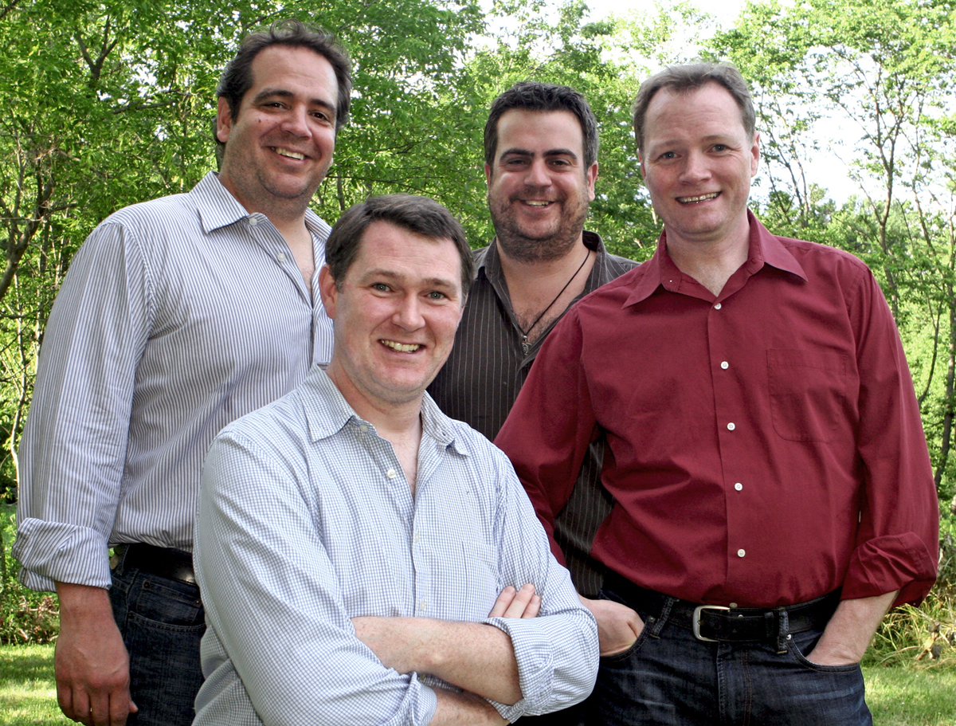

Ireland with The Makem & Spain Brothers
November 1st -10th, 2013

8 NIGHTS TO INCLUDE
- Armagh (3), Westport (3), Dublin (2)
- Roundtrip airfare non-stop with Aer Lingus Boston to Dublin
- Hotel accommodations for each night
- Deluxe motor coach for all transfers, touring and sightseeing
- Services of a professional Irish driver/guide throughout
- Welcome cocktail reception
- Breakfast daily, 6 hotel dinners music, throughout with The Makem & Spain Brothers.
FEATURING: Belfast City Tour, Titanic Experience, Traditional night at the Makem family private session house Tossie’s Pub, Antrim Coastline & Giant’s Causeway, Strokestown Park House & Famine Museum, Achill Island or Connemara, Dublin City Tour, Trinity College.
Tour Cost $2,716 - Based on double occupancy. Optional Travel Insurance $174
Single room supplement $429 (Book early limited available)
Optional Single Travel Insurance $ 196
To join this tour, complete this form along with check deposit of $200 per person (plus insurance fee of $174 or $196 per person if required) and made payable to Bracktours and mail to The Makem & Spain Brothers Registration, PO Box 524, Dover NH 03821-0524 or if paying by Credit card – email info@bracktours.com • Credit Card payment incurs a 3% charge.
Second Part Payment of $610 due by 16th June and final payment due by 27th August 2013
Is insurance required ☐Yes $174 Double occupancy; $196 Single Occupancy ☐No
Please indicate preferred form of payment: ☐Check/Bank draft OR ☐Mastercard/Visa via Paypal

Name(s) as it appears on passport ______________________________________________________

D.O.B eg 15 Mar 54 __________________________________________________________________

Sex: ☐M ☐F Room Type: ☐Double (1 bed); ☐Twin (2 beds); or ☐single (limited)

If double (one bed) or twin (2 beds) please list roommate:_________________________________________

Please print Email address ___________________________________Telephone _____________________

Address_______________________________ City _________________ State ____ Zip ___________

PLEASE LIST NAME(S) EXACTLY AS PRINTED ON YOUR PASSPORT.
Mob: +353 87 2597421 or US Toll Free 855-338 4339
E-mail: mailto:info@bracktours.com
Web: http://www.bracktours.com
11 Tamarisk Lawn | Kilnamanagh | Dublin 24 | Ireland

